Desalination within the water-energy-climate nexus

ABSTRACT
Population growth and increasing urbanisation, deteriorating infrastructure, poor water governance and climate change have the potential to further exacerbate water scarcity in South Africa. As such, the country has become increasingly interested in the potential to utilise large-scale seawater reverse osmosis (SWRO) plants to augment existing water supply options. This particularly applies to growing coastal metropoles such as eThekwini, the City of Cape Town (CoCT) and Nelson Mandela Bay Municipality (NMBM) where water demand increasingly steadily. While SWRO has been touted as a means of alleviating water scarcity, within South Africa’s coal dominated energy mix, it is energy intensive and could indirectly account for a significant increase in national greenhouse gas emissions (GHGs). With this in mind, the authors describe some of the background trends accentuating water scarcity in South Africa, how SWRO might be used as an adaptive response measure and some of the key consequences related to GHG emissions from SWRO water production. The analysis concludes that coupling SWRO with renewable energy technologies presents a more sustainable solution to water scarcity that conventional water production sourced from carbon intensive energy sources.
INTRODUCTION
South Africa is water-stressed and already uses existing freshwater resources intensively (DEA, 2013). The poor water endowment makes sound water management and major investment in water infrastructure a necessity for economic growth and poverty reduction. As such, seawater reverse osmosis (SWRO) in growing coastal cities is becoming an increasingly attractive option for water purveyors who have a constitutional mandate to supply potable water of a sufficient volume and quality to the populous. The sparked interest in SWRO is particularly evident in three growing South African metropoles - eThekwini, the City of Cape Town (CoCT) and Nelson Mandela Bay Municipality (NMBM). However, SWRO is energy intensive and South Africa’s current energy mix is carbon intensive. It is something of an irony that a water supply technology to increase resilience to climate change would, in turn, contribute to climate change. At the same time, South Africa has an abundance of renewable resources which become increasingly cost-competitive. If large-scale SWRO plants are deployed along growing metropoles in coastal regions, how will these plants contribute to climate change adaptation and the ability to alleviate water scarcity? What will the consequences be for the national GHG emissions inventory? What is the potential to mitigate these consequences through planning for large-scale SWRO by considering renewable energy alternatives?
FACTORS AFFECTING WATER AVAILABILITY IN SOUTH AFRICA
Population growth and water governance
Coastal metropoles play a significant role in South Africa’s landscape and economy. In 2013, of the national population, CoCT housed 7% (4 million people), eThekwini 6.6% (3.5 million people) and NMBM just over 2% (1.2 million people) (SACN, 2016; StepSA, 2015). Ethekwini and CoCT showed significant growth over the last few years, due to natural population growth and significant national and international in-migration (SACN, 2016). This has been prompted partly by a national developmental agenda to increase the economic productivity of large ports and expand the national economy around identified port industrial nodes.
Water supplied into the three bulk distribution networks range from 200 to 260 liters per person per day (l/p/d) (see Table 1 – DWS, 2015) versus approximately 100-150 l/p/d in European countries and 400 l/p/d for the United States. Although water is a capital intensive industry requiring a large capital outlay prior to cost recovery, South Africa has developed multi-year water storage capacity and an extensive system of inter-basin transfers to increase resilience to water scarcity. Most infrastructure has been developed, and is managed, by the national Department of Water and Sanitation. These require ongoing maintenance and investment in rehabilitation but have proven reasonably tolerant to underinvestment over protracted periods. Therefore, water utilities in South Africa can decline considerably but still ‘function’, albeit poorly.
In South Africa, ‘non-revenue water’ provides a proxy indicator for management efficacy. Table 1 shows non-revenue water, water losses and Infrastructure Leakage Index (ILI) data for CoCT, NMBM and eThekwini. There is some variability between metropoles and performance ranges from average in the case of CoCT; to poor in the case of eThekwini and NMBM.
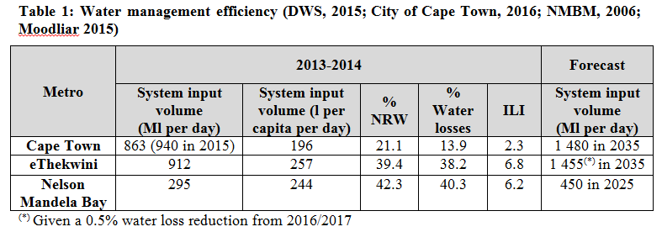
A recent review of water infrastructure serving South Africa’s cities, undertaken for National Treasury in 2016, concluded that “there is increasing evidence that the water reticulation network (through which water is distributed to customers) is becoming less reliable, resulting in more frequent and more severe unplanned water disruptions in many of South Africa’s cities and towns.” This suggests that while climate change and increasing population growth will play a significant role in accentuating water scarcity in South Africa, the ‘root’ cause of shortage of supply must be attributed to poor governance and lack of effective leadership (Auditor-General, MFMA 2014-15 consolidated general report on audited outcomes).

Climate change
Rainfall projections show a general drying pattern over South Africa, in particular in the south-west where the duration of dry spells is expected to increase (Engelbrecht et al., 2013). An increase in the frequency of both heavy and extreme rainfall events is likely over the eastern parts of the country during the summer months (Figure 1).
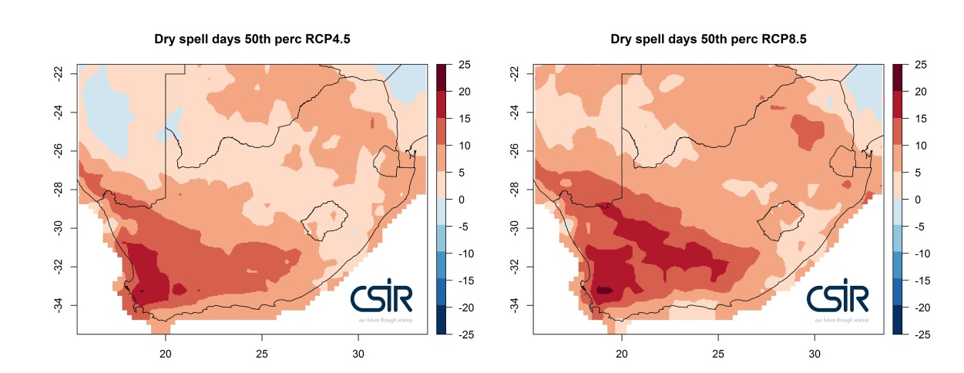
Figure 1: Projected changes in rainfall for South Africa measured as the number of dry spell days.

SEAWATER REVERSE OSMOSIS
Global installed desalination capacity in 2016 was 88 900 Ml/day, the majority comprising one of three technologies: reverse osmosis (RO) (67.1% of which 53 429 Ml/day is dedicated to SWRO), multi-stage flash (19%) and multi-effect distillation (7.2%) (IDA, 2017). Given improvements in RO energy efficiencies, preference is now afforded to SWRO whose energy consumption, while salinity dependent, ranges from 3.5kWh/m³ (39 000ppm) to 4.25kWh/m³ (46 000ppm) including pre-treatment. This is lower than multi-stage flash and multi-effect distillation which range from 4.7 to 7.3kWh/m³ of potable water (Fichtner, 2011).
The largest SWRO plant commissioned to date is the 540Ml/day Soreq SWRO plant in Israel. A number of small-scale RO plants have been installed in South Africa. Feasibility studies for larger scale SWRO plants (150 to 450Ml/day) are underway for Cape Town and Durban. Table 3 shows average values for capital expenditure (CAPEX), operational and maintenance costs and the cost of water production for desalination plants in the MENA region as well as projected costs for a 150Ml/day SWRO plant in South Africa.
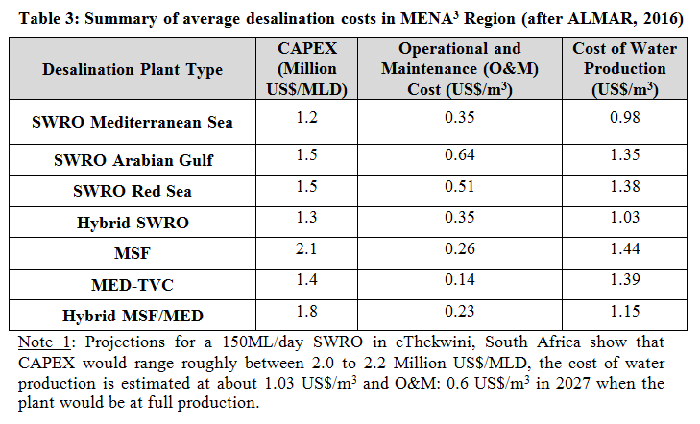
COUPLING SWRO WITH RENEWABLE ENERGY
While South Africa’s energy mix is still overwhelmingly dominated by domestic coal, the country has committed to developing 55 GW of renewable energy (wind and solar photovoltaic sources) by 2050 (DoE, 2016). The annual solar resource for CoCT, NMBM and eThekwini are 1900-1950kWh/m², 1700-1750kWh/m² and 1550-1700kWh/m² respectively.
Assuming a case-study of a 300Ml/day large-scale SWRO plant located in or near Cape Town. Based on a ratio of 1ha solar field per Ml (after ALMAR, 2016), this would require approximately a 300 ha solar field, corresponding roughly to a 150 MW solar PV farm.
Assuming 1.42 L of freshwater is used at coal-fired power stations in the production of 1 kWh electricity and approximately 1.03kg of CO₂ will be emitted to the atmosphere (ESKOM, 2012), equating to approximately 1.07kg CO₂-equivalents (CO₂eq) (Latterman, 2010) and based on an estimation of 0.11kg CO₂eq/kWh by a photovoltaic solar plant (Baldwin, 2017), coupling a large scale SWRO plant with supply from a solar farm would lead to carbon savings of 1 007 tons of CO₂eq per day. This constitutes 0.09% of South Africa’s greenhouse gas emission reduction policy of 428 Mtpa CO₂eq by 2050 (RSA, 2011).
The REIPPPP solar photovoltaic electricity price was probably determined for sites with near-ideal annual solar resource levels of ≥2 000 kWh/m². Based on the solar resources in the vicinity of the CoCT, this suggests that large-scale photovoltaic plants built for SWRO may generate electricity at costs, in the order of, of ZAR 0.64/kWh.
For Cape Town, electricity costs have been calculated at approximately 64 ZARc/kWh for solar power (= ZAR 2.24/m³ potable water) and range from ZAR 1.07 to ZAR 1.14/kWh for municipal electricity during standard demand (=ZAR3.75 to ZAR 5/m³ potable water). Supplying a SWRO SWRO plant in Cape Town with solar energy would therefore lead to roughly a 41 to 44% electricity cost savings, which can be translated to roughly 20% O&M costs savings (given that electrical energy makes up for approximately 51% of O&M costs). To guarantee a reliable production of potable water, it is however still recommended to have the municipal grid as a back-up for when supply is insufficient and as a customer of excess electricity generated on good days.
DISCUSSION
South Africa is facing significant challenges to matching increasing water demand with limited supply options, reduced water quality and inefficient use of existing infrastructure and resources.
It seems evident that significant attention should be paid to the reduction of water losses from poorly maintained infrastructure and further implementation of water conservation and water demand management strategies, including the re-use of water particularly in coastal cities where wastewater is lost to sea via marine outfall. A reduction of water losses requires better asset management and maintenance/refurbishment of infrastructure by all institutions in the country as well as an improvement in effective leadership and governance in affected municipalities (Auditor-General, MFMA 2014-15 consolidated general report on audited outcomes).

There is an increasing interest in SWRO as an option to alleviate water scarcity. This trend is intensified by the impacts of climate change on available surface- and groundwater resources. In this respect, the South African National Water Resource Strategy 2 (DEA, 2013) and the National Desalination Strategy (DWS, 2011) both envision the use of SWRO in coastal regions of the country as a long-term strategy to respond to an increasing water demand.

Climate change mitigation takes preventive actions through reduction of GHG emissions, while climate change adaptation is generally an iterative process of avoiding harm and exploiting opportunities (Field et al., 2014). SWRO can be seen as an adaptation option, as it strives to augment existing water supplies that may be vulnerable to a changing climate. However SWRO is energy intensive and thus with a majority of South Africa’s energy coming from coal, is also emissions intensive (DEA, 2016). Without use of low-emission energy sources such as renewable energy sources, an increased use of SWRO with the current energy mix would increase GHG emissions and contribute negatively to climate change mitigation efforts.
The extent to which energy requirements are likely to place constraints on the adoption of SWRO plants in line with national commitments to carbon emission reduction is to be considered. Cape Town, Port Elizabeth and Durban are known for suitable solar and wind energy. The coupling of SWRO desalination plants with renewable energy in the studied coastal cities and the continuous improvement in energy efficiency of desalination technologies therefore has the potential of providing a sustainable and environmental friendly source of potable water. Additionally, where there is sufficient waste heat available, desalination technologies such as multi-effect distillation, may also be considered, for example, adjacent to a nuclear power station facility or a refinery, as it is the case for Cape Town and Durban respectively.
Although resources are not an absolute constraint, South Africa’s low economic growth and high indebtedness constrain the availability of government grants and more reliance will need to be placed on commercial finance to support investments in urban water infrastructure. Urban water projects lend themselves to project finance and a desalination plant serving a city could be financed this way.

REFERENCES
ALMAR, 2016. Desalination Technologies and Economics: CAPEX,OPEX & Technological Game Changers to Come. Mediterranean Regional Technical Meeting, December 12-14. Marseille.
Baldwin, S., 2017. Carbon footprint of electricity generation. Retrieved February 08, 2017, from http://www.geni.org.
City of Cape Town, 2016. City of Cape Town Medium Term Infrastructure Investment Framework 2016/2017 – 2017/2018. Unpublished report.
DEA, 2016, South Africa National Adaptation Strategy (Draft for comments).
DEA, 2013. National Water Resource Strategy, Second Edition.
DoE, 2013. Integrated Resource Plan for electricity (IRP) 2010 - 2030: Update Report.
DoE, 2016. Integrated Resource Plan Update: Assumptions, Base case and observations, Rev1, Draft.
DWS, 2015. A Water Balance Assessment of South Africa’s Metropolitan Municipalities.
DWS, 2011. National desalination strategy.
Engelbrecht, C., Engelbrecht, F., Dyson, L., 2013. High resolution model projected changes in mid tropospheric closed lows and extreme rainfall events over southern Africa. International Journal of Climatology 33, 173-187.
Eskom, 2012. Annual Integrated Report.
Field et al., 2014. Technical summary. In: Climate Change 2014: Impacts, Adaptation, and Vulnerability [Field, C.B., et al. (eds.)]. Cambridge University Press, Cambridge, United Kingdom and New York, NY, USA, pp. 35-94.
Fichtner, 2011. MENA Regional Water Outlook Part II: Desalination Using Renewable Energy Task 1 – Desalination Potential. Stuttgart.
IDA, 2017. IDA Desalination Yearbook 2016-2017. Retrieved from http://idadesal.org.
Latterman S., 2010. Development of an EIA and decision support system for seawater desalination plants.
Meinshausen, M., Smith, S.J., Calvin, K., Daniel, J.S., Kainuma, M., Lamarque, J., Matsumoto, K., Montzka, S., Raper, S., Riahi, K., 2011. The RCP greenhouse gas concentrations and their extensions from 1765 to 2300. Climatic Change 109, 213-241.
Moodliar, S, 2015. Ethekwini Municipality Planning of Water and Sanitation. Presentation at the Miles Master Class. Accessed on 25 January 2017at http://www.mile.org.za.
Nelson Mandela Bay Metropolitan Municipality, 2006. Water Master Plan 2005-2020. Unpublished Report. Accessed at http://www.nelsonmandelabay.gov.za/datarepository/documents/water-master-plan-2005-2020.pdf on 1 February 2017.
RSA, 2011. The Government of the Republic of South Africa, National Climate Change Response White Paper, Pretoria, October 2011.
SACN (South African Cities Network), 2016. State of South African Cities Report, 2016.
StepSA, 2015. Town growth profiler, based on SACN/CSIR Settlement Typology and CSIR Mesoframe Socio-Economic Indicators 2014. https://docs.google.com/spreadsheets/d/1P6vQCLvk5HZKHdDHLu55NGT5jA2fyjxUliec035Vnp8/pubchart?oid=550799582&format=interactive.

Non-revenue water refers to all the water that is lost through physical leakage or commercial losses (meter under-registration, billing errors, theft etc.) as well as any unbilled authorised consumption (fire-fighting, mains flushing etc.).
Based on Representative Concentration Pathways (RCPs), RCP 8.5 and RCP 4.5, which assume different paths of development for the world. RCP 4.5 describes a future with relatively ambitious emission reductions and RCP 8.5 with no reductions in emissions (Meinshausen et al., 2011).
Middle East and North Africa
CO₂eq is a measure used to compare the emissions from various greenhouse gases based upon their global warming potential.

